For Office Use Only: Application Recieved____/_____/_______
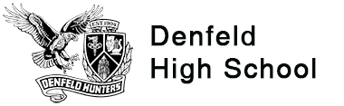

Denfeld After School Happenings: DASH
ALL FREE * DTA Passes Available

Completed registration forms can be turned into the Denfeld High School front desk, or emailed to the
Denfeld Community School Coordinator, Saraiya Piantek. Please reach out with any questions.
Email: nd.saraiya.piantek@isd709.org Phone: (218) 336-8830 x2032 Cell: 218-216-3052 (call/text)

Program Registration Information
This registration form covers the full program year - June 2021 through May 2022- and will be effective for student participation starting on the date it is received, unless noted here.
Please check all program sections you want to enroll for.
June-July 2021 Summer Session_______ September 2021-May 2022 School Year Session_______
General Information

Student’s Name:_______________________________________________________Birth date:___________________

Address:_______________________________City:__________________State:_______Zip:_____________

Parent/Guardian Name(s) & Relationship(s): _______________________________________________________________________________________________

Phone (please list at least 2):_________________________________________________________________

Email:_______________________________________
Student’s Phone (if ok to contact related to program): _____________________________ Text? Y or N

Emergency Contacts
The parent/ guardian will always be the primary contact. Staff will only contact listed emergency contacts in situations where parent/guardian can’t be reached.

Emergency Contact Person:________________________________________Phone: ___________________

Relationship to student: ________________________ Address: _____________________________________

More About You/Your Student
Please share with us how you hope DASH can support you/your student:
________________________________________________________________________________________

_______________________________________________________________________________________
Something that’s important for staff to know about me/my student and/or the culture of my family is:

______________________________________________________________________________________

______________________________________________________________________________________

Student Preferred Pronouns: ___________________ Does your student need any accommodations:______

________________________________________________________________________________________

GUARDIAN AGREEMENT
I understand participants are expected to follow the rules established for the DASH program and to cooperate with staff, instructors, and volunteers in the best interests of the program and its participants.

DASH staff reserve the right to suspend from the program, youth who create conflict, unsafe situations, or ignore staff direction, including refusal to comply with COVID safety guidelines.

Students will be provided a bus pass, if needed, to get to and from programming. Transportation may be provided for field trips. Permission slips will be sent home for any planned field trips.

I am a legal guardian of the student named on this document. This student has my permission to participate in the DCSC Denfeld DASH Program. I hereby release the Duluth Community School Collaborative, partner organizations, staff, instructors, and volunteers from all claims arising from any accident, injury, or illness which may occur as a result of their participation in the DASH program. I also agree to be liable to pay for any needed emergency medical treatment including ambulance, in the case that contacting the guardian and emergency contact was attempted and were unable to reach.

By signing this form, I acknowledge that I have read and understand the information on both sides of this form and consent to this student’s voluntary participation in the DASH program.

Parent/Guardian Signature Date

____ Initial Here if you give permission for the Denfeld community school coordinator to share relevant information about this student with the Boys & Girls Club, Lifehouse, Valley Youth Center and Harbor Highlands YMCA as needed with the purpose of providing a support network for them across school, home, and community.

____ Initial Here if you WOULD NOT LIKE this student to be given DTA bus passes after participating in DASH activities to get home.

____Initial Here if you DO NOT give permission to the Duluth Community School Collaborative and Denfeld High School to use photos of your student for promotional purposes.

Follow us on Facebook! Denfeld Community School
Follow us on Instagram! @Denfeld_Community_School
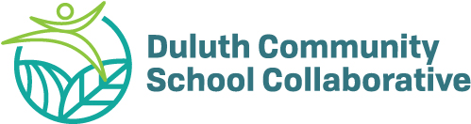

DASH is a program of the Duluth Community School Collaborative in partnership with Denfeld High School

